M. Helliwell and Mme Annie’s went on a field trip to Kosick Holdings Gravel Pit to collect rocks for an ADST activity. They will be painting kindness rocks as part of our school values. The rocks will then be given to someone. Huge thank you to Tyler Kosick and Mike for allowing our students to spend some time in the gravel pit.

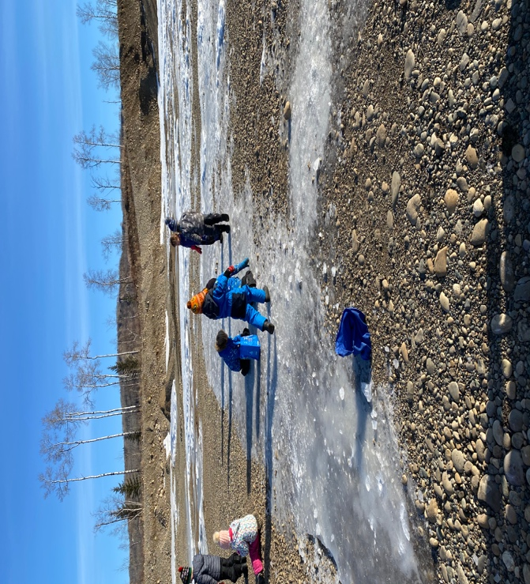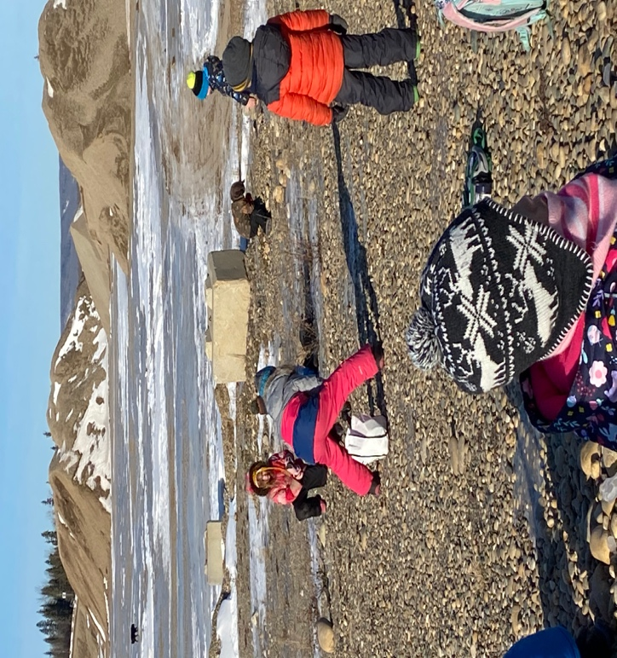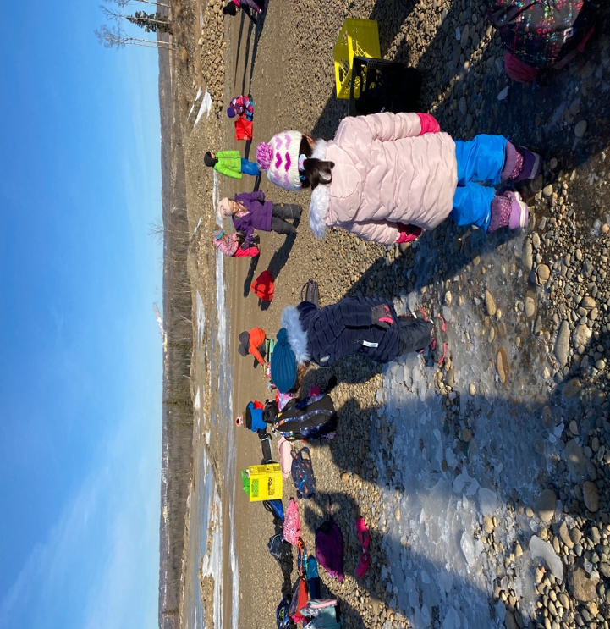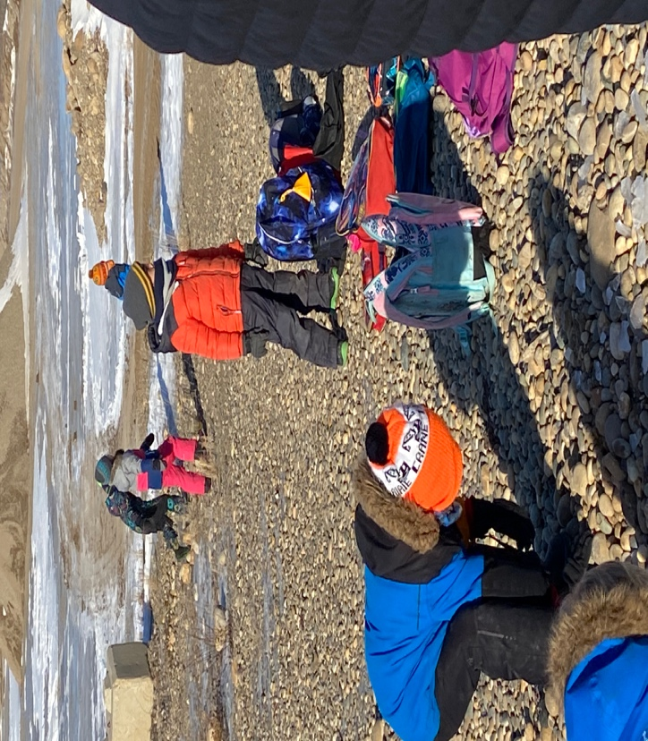

Mme Stéphanie and Mme Nouha’s classes are learning about diversity through an ADST activity involving felting. The lesson helped the students recognize that we are all different. Each colour represents a character trait. The completed project is a key chain.
