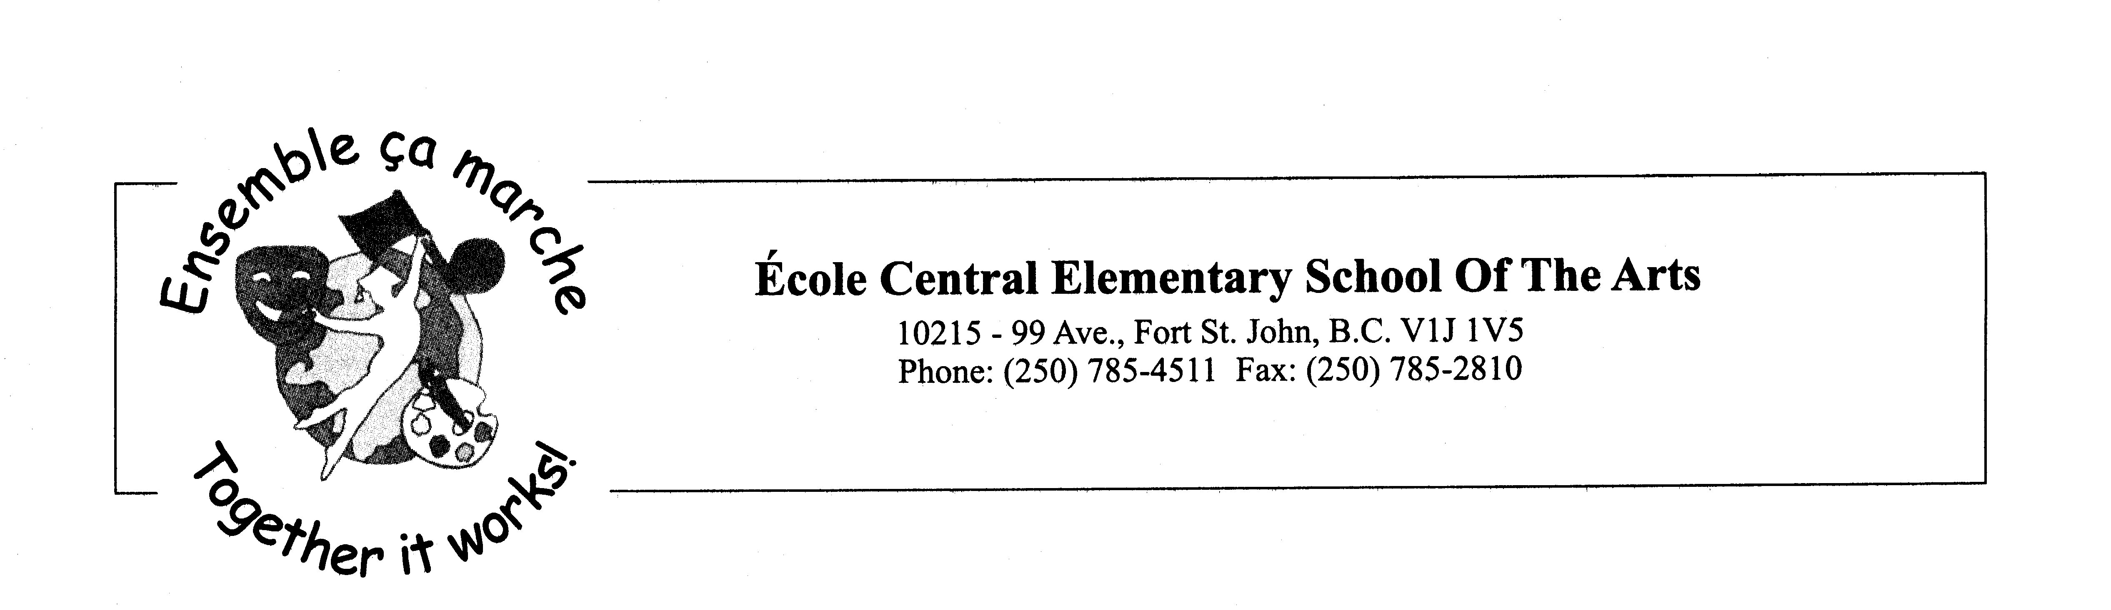
Friday, March 26, 2021

Hello Parents and Students,

I hope you have all had a wonderful spring break. We are looking forward to seeing you on Monday. I can hardly believe that we only have 3 months left for this school year.

Please read through the letter for some important information for the next few months.

Spring is here, hopefully! We have had a lovely winter/spring so far but the weather can still be cold in the mornings. Please ensure your child is dressed appropriately to go outside. As we move into spring/mud season, you may want to send a change of clothes for your child to avoid phone calls home for dry clothes.

Purdy’s Fundraiser: If you purchased any chocolates, we will be sending home your order on Tuesday or Wednesday. If you do not want your child to bring it home on the bus, please contact the office and we will meet you at the door with your order.

Central Swag Clothing: If you purchased any Central swag, we will be sending home your order on Monday. If you do not want your child to bring it home on the bus, please contact the office and we will meet you at the door with your order.

FSA Assessments: Grade 4 students have completed the FSA assessments and they have been scored. Teachers will be sending them home with your child on Wednesday, March 31st. Please let the office know if you do not receive your child’s booklet.

Spirit Days: We continue to have spirit days planned for the remainder of the year. We encourage your child to participate in these days to help build community. Our next spirit day is Thursday, April 1st. We will be having a Twin Day.

Calendars: Please continue to check the monthly calendars for our upcoming events, hot lunch menu items for each day, ProD days, and spirit days. Please check back often as it will be updated when things pop up. Here is the link:
https://docs.google.com/document/d/1Cj68bgpnqvxi5R2G1Lj8JSvSASKGCTwf-oYAVfMQ0tw/edit?usp=sharing

Popcorn Days: We have three more popcorn days planned (Thursday, April 22, Friday May 21, and Friday, June 18). Don’t forget to order your popcorn on the Hot lunch menu site.

Hot Lunch Menu: Below you will find the instructions on how to login to our Hot Lunch Website. The orders for April are due Monday, March 29th 2021. Please do not forget to pay for your orders when you place them.
1. All orders will be placed online at this web address:
central.hotlunches.net
2. To place orders you will need to register first. The access code is ECEHL (these need to be capital letters)
3. Fill in the registration page with your contact information.
4. Add your children to the correct classroom.
5. Place your orders. You can do one month at a time or all four months if you wish.
6. You will need to pay for your order with a credit card. We use Bambora to collect money. Unfortunately, we cannot accept cash or cheques.
8. You will be charged a $0.30 fee to use the Bambora service. If you want, you can pay for all the orders at once to have only one fee.

Class Photos: The photographer will be at Central on April 22nd in the morning for the class photos. More details to come.

French Immersion Kindergarten Registrations: We still have room for any student beginning school. Please pass this message along to anyone looking to register their child for French Immersion.

Easter Long Weekend- reminder that students will have a long weekend when we return.

As always, if you have any questions or concerns please feel free to contact us by telephone or email. Many thanks for your support!

Sincerely,

Mme Côté-Aubin Mr. Brooks
Principal Vice-Principal
lcoteaubin@prn.bc.ca jbrooks@prn.bc.ca

Facebook: https://www.facebook.com/sd60ec/
Central Website: https://central.prn.bc.ca/

March Dates
29th - School Reopens - Welcome Back
30th - Band Recruiting for grade 5 students- gym at 12:45 pm

April Dates
1st - Twin Day
2nd - Good Friday- No School
5th - Easter Monday - No School
9th - Pink Shirt Friday
16th - Jersey Day
22nd - Class Photos – AM
22nd – Popcorn Day
23rd - Pro-D- no school
30th - Superhero Day

May Dates
6th - Pink Shirt Day
7th - NID - Pro-D
13th - Retro Day- 60, 70, 80's Day
20th - Inside out Day
21st – Popcorn Day
24th - Victoria Day - No School

