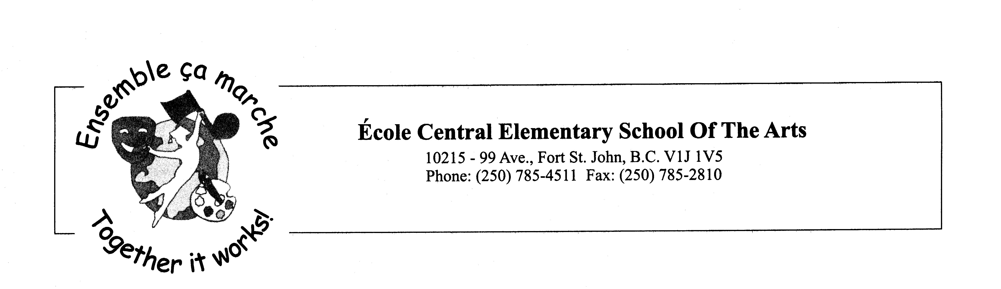
March 3, 2021

Dear Parents and Guardians:

During the months of January to April, School District 60 is participating in the 2021 Ministry of Education Electronic Anonymous Student Learning Survey Project in cooperation with all other school districts throughout the Province.

Parents/Guardians/Caregivers can complete the online Anonymous Student Learning Surveys any time before 11:59 pm April 30th, 2021, providing immediate results to the school and the district.

For 2021: Students in Grades 4, 7, 10 and 12 complete the survey; Parents/Guardians/Caregivers of Grade 4, 7, 10 and 12 Students complete the survey; and all Staff associated with a School complete the survey.

To complete the survey:
- Go to any computer that has an up-to-date internet browser access at home, work, or school.
- Go to www.bced.gov.bc.ca/sat_survey/access.htm
- Under the section Direct Access – no logon number required select:
  - District: the name of your child’s district
  - School: the name of your child’s school
  - Language: the language of your choice
- Complete the survey by clicking on the appropriate circle to answer each question. Move to the next set of questions by clicking on the right arrow in the bottom right corner of the screen. Click on the left arrow to navigate backwards.
- When you are finished the survey, you will get a message “Thank you for sharing your views”.
- Once complete, your school will have the results immediately.

Thank you for participating in this innovative project.

Mme Côté-Aubin

