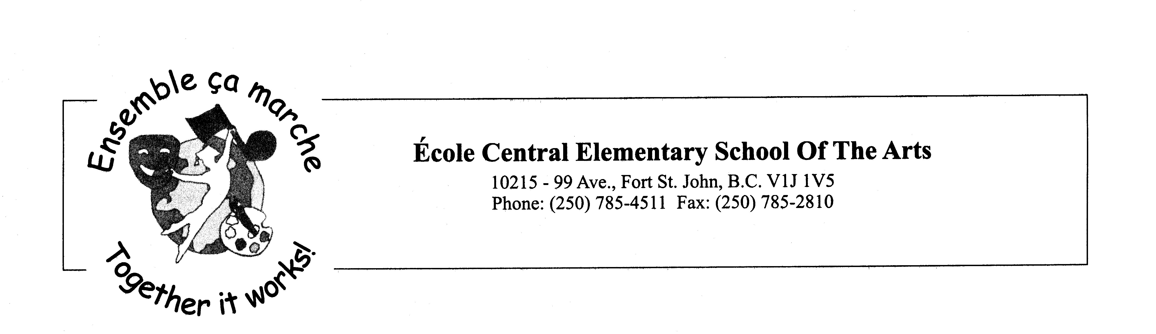
Saturday, April 17, 2021

Hello Parents and Students,

I hope you are enjoying the beautiful sunshine.

Please read through the letter for some important information for the next few months.

Playground: We continue to have several students coming to the office because they are wet or muddy. Please consider sending them to school with a change of clothes to avoid phone calls home for dry clothes.

Classroom Photo: We will have a class composite instead of a class photo. Our photographer, Tanya Hart, with Photography by Hart will print them on a 5x7 and include a cardboard frame. They will be free of charge. A huge thank you to Tanya!

School: We would like to remind our parents to please call ahead before entering the school as per the Provincial Health Order and the School District Health and Safety Protocols.

Scholastic Virtual Book fair: Our virtual/online spring book fair is coming up. Your books will be delivered directly to your home. The online store will be open from April 26th to April 30th, 2021. More information to follow with the link.

Spirit Days: We continue to have spirit days planned for the remainder of the year. We encourage your child to participate in these days to help build community. Our next spirit day is Friday, April 30th. We will be having a Superhero Day.

Calendars: Please continue to check the monthly calendars for our upcoming events, hot lunch menu items for each day, ProD days, and spirit days. Please check back often as it will be updated when things pop up. Here is the link:
https://docs.google.com/document/d/1Cj68bgpnqvxi5R2G1Lj8JSvSASKGCTwf-oYAVfMQ0tw/edit?usp=sharing

Popcorn Days: We have three more popcorn days planned (Thursday, April 22, Friday May 21, and Friday, June 18). Don’t forget to order your popcorn on the Hot lunch menu site.

Hot Lunch Menu: Below you will find the instructions on how to login to our Hot Lunch Website. The orders for May are due Saturday, May 1st 2021. Please do not forget to pay for your orders when you place them.
1. All orders will be placed online at this web address:
central.hotlunches.net
2. To place orders you will need to register first. The access code is ECEHL (these need to be capital letters)
3. Fill in the registration page with your contact information.
4. Add your children to the correct classroom.
5. Place your orders. You can do one month at a time or all four months if you wish.
6. You will need to pay for your order with a credit card. We use Bambora to collect money. Unfortunately, we cannot accept cash or cheques.
8. You will be charged a $0.30 fee to use the Bambora service. If you want, you can pay for all the orders at once to have only one fee.

Pitch-In Day: Our school will be participating in the Fort St. John Pitch-In Day campaign. We will be cleaning collecting garbage around our school on April 27th.

French Immersion Kindergarten Registrations: We still have a few spots for any student beginning school. Please pass this message along to anyone looking to register their child for French Immersion.

ProD Day- reminder that students will not have school on Friday, April 23 and May 7, 2021.

As always, if you have any questions or concerns please feel free to contact us by telephone or email. Many thanks for your support!

Sincerely,

Mme Côté-Aubin Mr. Brooks
Principal Vice-Principal
lcoteaubin@prn.bc.ca jbrooks@prn.bc.ca

Facebook: https://www.facebook.com/sd60ec/
Central Website: https://central.prn.bc.ca/

April Dates
22nd – Popcorn Day
23rd - Pro-D- no school
26th – Scholastic Book Fair begins
27th – Pitch-In Day
30th - Superhero Day and Scholastic Book Fair ends

May Dates
1st – Hot Lunch Orders for May are due

6th - Pink Shirt Day
7th - NID - Pro-D
13th - Retro Day- 60, 70, 80's Day
20th - Inside out Day
21st – Popcorn Day
24th - Victoria Day - No School
30th – Hot Lunch Orders for June are due

June Dates
4th - Pink Shirt Day
9th - Beach Day / Hawaiian Day
17th- Mustache Day
18th – Popcorn Day
24th - Last Day for Students

