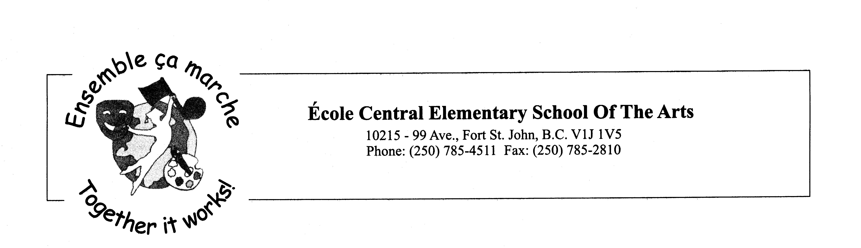
Saturday, May 15, 2021

Hello Parents and Students,

We can hardly believe that there are only 6 weeks left of school. Please read through the letter and feel free to call or email if you have any questions.

After School Pick Ups: We want to remind you that we only have supervision until 3:10 at the end of the day. We know that parents make their best effort to pick up their child before or close to the time. We also understand that sometimes parents can be detained, if this happens please call the school and we will ensure your child is kept safe at the office.

Interim Reports: Some teachers have sent an interim report this past week if you did not receive one in February, 2021. Please check with your child’s teacher if you have any questions.

Art Cards: The art card orders are due on May 17, 2021. The cards will be shipped to the school and we will distribute them to students to take home.

School Supplies: In September 2021, we would like to offer school supplies to families at a cost of $35.00/child for primary and $40.00/child for intermediate students. This alleviates families from having to search out lists and supplies. We buy our supplies in bulk and as a result we get great prices, which we pass along to our families. It also ensures that students receive the supplies that their specific teacher wants to use.

Popcorn Days: We have two more popcorn days planned (Friday, May 21, June 18). Don’t forget to order your popcorn on the Hot lunch menu site. It is listed under May and June Popcorn Day in the menus.

Garden Beds: We would like to invite families to use the garden beds. We have a few classes that will be planting flowers and vegetables but we have some available. Please let me know if you would like to use some of the beds to plant some vegetables or flowers with your family.

COVID-19: This is a friendly reminder, if you need to pick up your child early for an appointment or drop off something, please call the school and someone will meet you at the main doors. We ask that you not enter the school unless you have an appointment. If you have an appointment, you will be required to enter through the main doors, wear a mask, read through the health check, hand sanitize, and sign in.

Please ensure that you continue to do the daily health check with your children as per District Safety protocol. Any students or staff who show symptoms, must stay home.
Any child who becomes sick during the day will be isolated at the office until a parent or guardian can pick them up.

I have attached the K to 12 Health Check. Parents and Caregivers can utilize this app for daily assessment of symptoms. https://www.k12dailycheck.gov.bc.ca/healthcheck?execution=e1s1

Hot Lunch Menu: Below you will find the instructions on how to login to our Hot Lunch Website. The orders for June are due Sunday, May 30th 2021. Please do not forget to pay for your orders when you place them.
1. All orders will be placed online at this web address:
central.hotlunches.net
2. To place orders you will need to register first. The access code is ECEHL (these need to be capital letters)
3. Fill in the registration page with your contact information.
4. Add your children to the correct classroom.
5. Place your orders. You can do one month at a time or all four months if you wish.
6. You will need to pay for your order with a credit card. We use Bambora to collect money. Unfortunately, we cannot accept cash or cheques.
8. You will be charged a $0.30 fee to use the Bambora service. If you want, you can pay for all the orders at once to have only one fee.

French Immersion Kindergarten Registrations: We still have room for any student beginning school. Please pass this message along to anyone looking to register their child for French Immersion.

As always, if you have any questions or concerns please feel free to contact us by telephone or email.

Sincerely,

Mme Côté-Aubin Mr. Brooks
Principal Vice-Principal
lcoteaubin@prn.bc.ca jbrooks@prn.bc.ca

Facebook: https://www.facebook.com/sd60ec/
Central Website: https://central.prn.bc.ca/

May Dates
17th – Art Card Orders are due
20th - Inside out Day
21st – Popcorn Day
24th - Victoria Day - No School
June Dates
4th - Pink Shirt Day
9th - Beach Day / Hawaiian Day
17th - Mustache Day
18th - Popcorn Day
24th - Last Day for Students
24th - Report Cards go home

