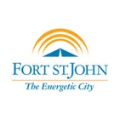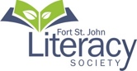https://www.prn.bc.ca/wp-content/themes/prn__district/library/images/prn__logo.png

**Participating Service Providers –**

**School District 60 SWIS**

**Fort St John Literacy Society**

**Employment Connections**

**SUCCESS**

**City of Fort St John**

**Fort St John Public Library**

**Drop in to gather information on all services provided by participating community members! There will be information on education, literacy, employment, City services and Library Programs!**

**Limited Spaces Available!**

**Following BC Provincial Health Mandates**

**Vaccination Passports will NOT be required, as we will regulate the attendance to remain under 50 people indoors at all times.**

***Masks will be required***

**YOU’RE INVITED!**

**Please join us for a Community Newcomer Service Provider Drop-In…**

**Friday September 24th, 2021**

**Festival Plaza**

**(near Centennial Park)**

**10:00am – 1:00pm**