Together it Works/Ensemble ça marche!
Saturday, October 30, 2021

École Central Elementary School of the Arts


Month at a glance…

November Dates

10th- Camo or Plaid Day
11th - Remembrance Day - No School
19th - Lockdown practice at 11:30
19th – Popcorn Day
22nd- Report Cards Go Home
24th - Early Dismissal Day 1:55 pm
25th- Crazy Socks Day
25th - Early Dismissal Day 1:55 pm
26th - NID - Parent/Teacher Interviews

Dear Parents,
We are already at the beginning of November! No Snow Yet!
By now you should have received an interim report for your child. If you have any questions or concerns, please don’t hesitate to contact your teacher. The first formal report card will come out at the end of November.
Yesterday, our school had a costume day and we were pleased to see the participation level in the school.
“Shrek” rehearsals are well on their way (every Monday, Wednesday and after school until 4pm) – a special thanks to the staff working on this production. As we get closer to the date (February) we will probably need more assistance. Please contact the school if you are able to help out.
Canteen Orders for November are due today. Please do not forget to pay for your order when you place it.
French Immersion Kindergarten Registrations: Just a reminder that at this time, registrations for French Immersion Kindergarten students for 2021/22 are open to families who have siblings already attending Ecole Central Elementary or in the French Immersion programme (Bert Bowes/NPSS). Starting on January 4, 2022, French Immersion Kindergarten will be open to the public. Please call the school if you want us to send a registration form home with a sibling.
Purdy Orders are due on Wednesday, November 10, 2021. Not only is this a good way to support your child’s classroom activities but you can also purchase Christmas gifts.
Central Swag has arrived. It will be sent home on Monday with your child.
Lock Down Practice: We will have a lock down practice Monday, November 19 at 11:30 am. We will be unavailable during the practice as all staff participate. We understand these can be stressful for our student but we will prepare them as best as we can previous to the practice. The lock down practices will never be a surprise. We encourage you to talk about it with your child/children at home also. Please let us know if you have any questions.
Central Calendar check it out if you haven’t already done so.
https://docs.google.com/document/d/1Cj68bgpnqvxi5R2G1Lj8JSvSASKGCTwf-oYAVfMQ0tw/edit?usp=sharing

Please don’t hesitate to call or email if you have any questions or concerns.

Sincerely,
Mme Côté-Aubin Mr. Brooks
Principal Vice-Principal

- Costume Day- Staff photo of our villains.

Happenings/Websites
- Our students finally got to play volleyball.
- Thank you to Mme Stéphanie and Mme Janelle for coaching our teams.

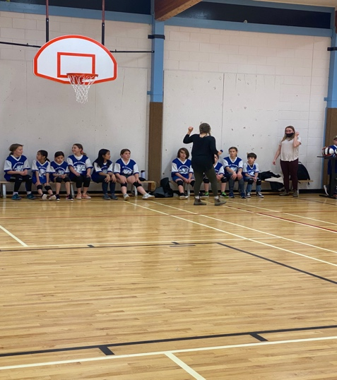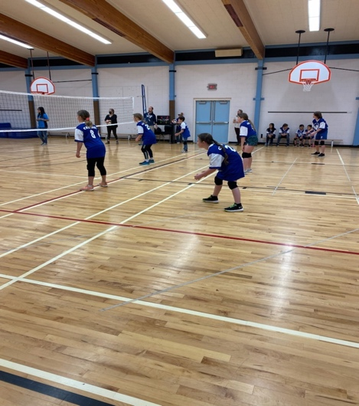

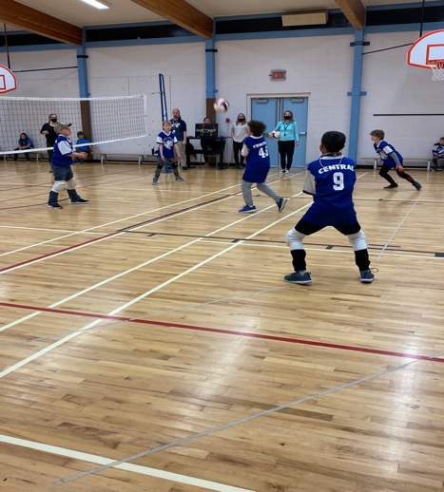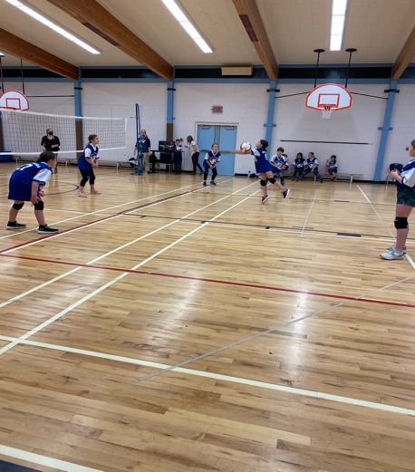

Happy Halloween!

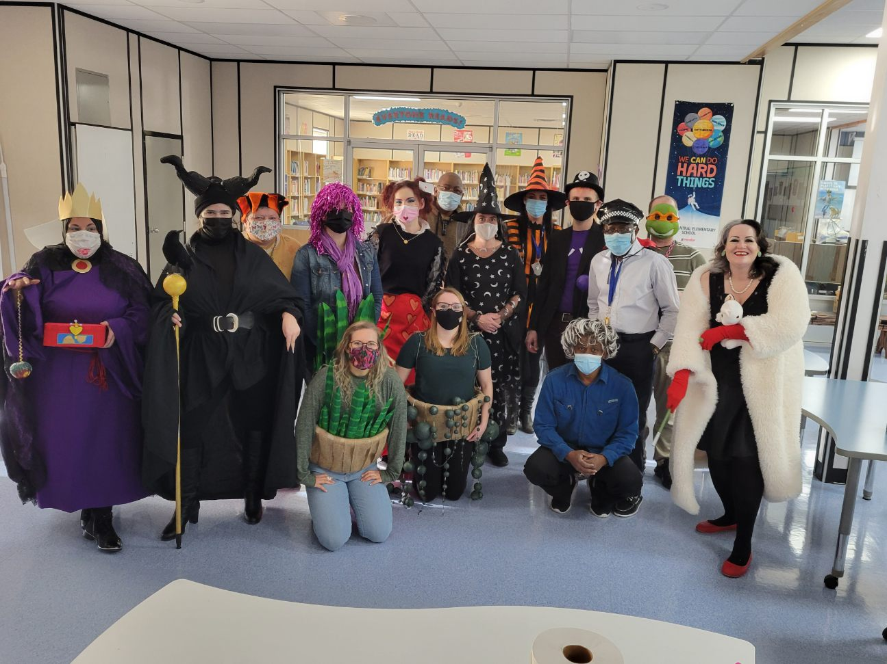

Facebook: https://www.facebook.com/sd60ec/
Central Website: https://central.prn.bc.ca

