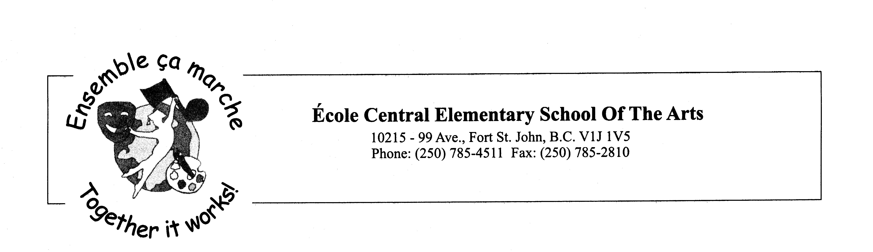
October 13, 2021

Dear Parents and Guardians,

We will be selling Purdy’s chocolates once again this year. This program gives 25% of the sales back to our school. The profits will go to your child’s classroom fund. Purdy’s chocolates are made fresh in Vancouver from only 100% sustainable cocoa. They have a great selection of chocolate gifts so you can help us out while you get your Christmas shopping done.

Orders can be placed online or by order form.
Order Online:
1. Login or create a new account at www.purdysgpp.com/8670. It may ask you for our customer number which is: 22019
2. Click JOIN GROUP.
3. Place and pay your order.
4. REMINDER- in the section- ADDITIONAL INFO: Can you please add your child’s name as well as the teacher name so we can track the order?

If you are ordering by paper form, please fill out the order form and return it to school.

Please place and pay for orders by Wednesday November 10th, 2021. You may pay for your orders by cheque or money. Please make cheques out to Ecole Central Elementary.

The orders should be in the last week of November.

All questions or emails may be forwarded to lcoteaubin@prn.bc.ca

Thank you,

Lynne Côté-Aubin
Principal

