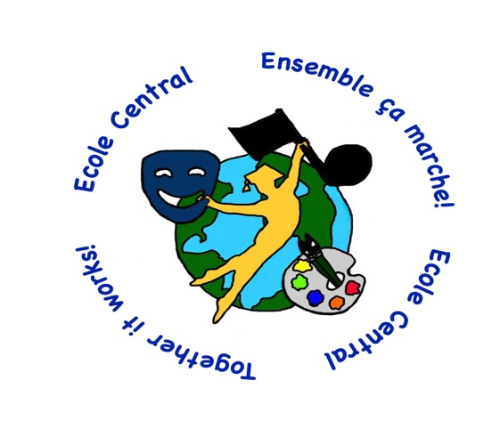

Why should you enroll your child in the kindergarten or grade 1 French Immersion Programme?

French Immersion has been very successful all over Canada. It is an excellent way for your child to become fluent in French within the public school system and graduate with a Dual Dogwood Diploma. There are many advantages and benefits for enrolling in the French immersion programme such as being able to speak another language while travelling to other parts of Canada and the world, reading and understanding French opens the door to many Francophone cultures and career opportunities, and knowing a second language makes it easier to learn a third or even a fourth language. For more information contact the school at 250-785-4511 or email lcoteaubin@prn.bc.ca

